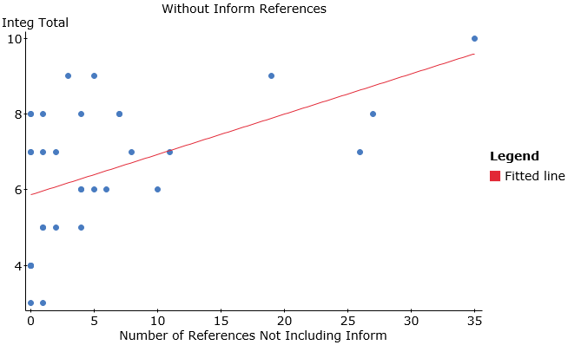

**This scatterplot indicates a moderate to strong positive linear correlation between essay score and the number of non-inform references used in the essay. The significance test shows that this relationship is highly significant (p=.0029).**

**Simple linear regression results:**   
Dependent Variable: Integ Total   
Independent Variable: RefsNotInform   
Integ Total = 5.8593636 + 0.10639692 RefsNotInform  
Sample size: 33  
R (correlation coefficient) = 0.50157321  
R-sq = 0.25157569  
Estimate of error standard deviation: 1.6165601

**Analysis of variance table for regression model:**

| **Source** | **DF** | **SS** | **MS** | **F-stat** | **P-value** |
| --- | --- | --- | --- | --- | --- |
| Model | 1 | 27.231162 | 27.231162 | 10.420354 | 0.0029 |
| Error | 31 | 81.011262 | 2.6132665 |  |  |
| Total | 32 | 108.24242 |  |  |  |