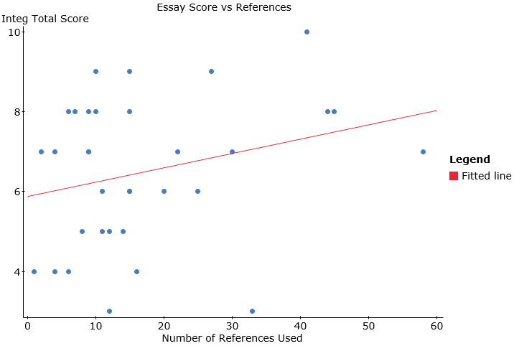

**The scatterplot indicates a possible weak positive linear correlation between essay score and the total number of references used in the essay. The significance test below shows that this relationship is not significant (p=0.131).**

**Simple linear regression results:**   
Dependent Variable: Integ Total   
Independent Variable: RefsTotal   
Integ Total = 5.870289 + 0.035831204 RefsTotal  
Sample size: 33  
R (correlation coefficient) = 0.268372  
R-sq = 0.072023529  
Estimate of error standard deviation: 1.8000576

**Analysis of variance table for regression model:**

| **Source** | **DF** | **SS** | **MS** | **F-stat** | **P-value** |
| --- | --- | --- | --- | --- | --- |
| Model | 1 | 7.7960014 | 7.7960014 | 2.4060194 | 0.131 |
| Error | 31 | 100.44642 | 3.2402072 |  |  |
| Total | 32 | 108.24242 |  |  |  |